|  |
| --- |
|  |

|  |
| --- |
| **PSpice** |
|  |
|  |
|  |
|  |
|  |
|  |
|  |

**Introduction to PSpice**

Simulation Program with Integrated Circuit Emphasis

Developed in 1970`s at Berkeley

Many commercial versions are available

HSPICE is a robust industry standard

SPICE is general purpose analog circuit simulator that is used to verify circuit designs and to predict the circuit behavior.

PSpice is a PC version of SPICE that runs on workstations and larger computers.

**PSpice Units**

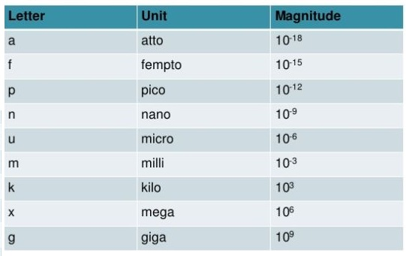

**PSpice elements & their donated letter**

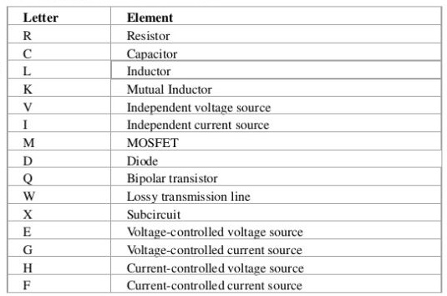

**Flow Chart of PSpice**

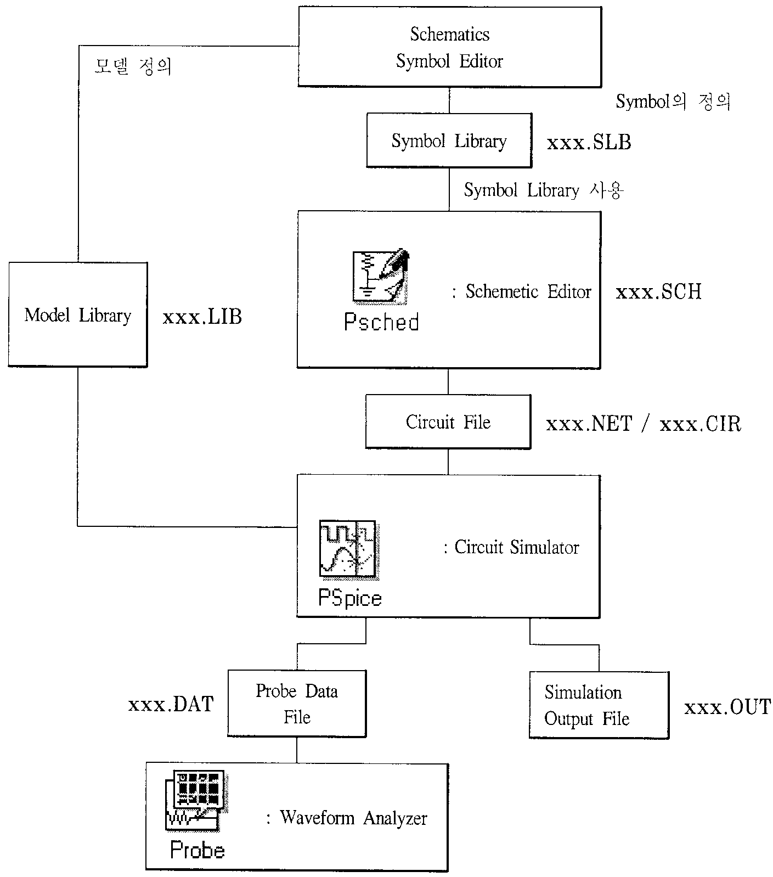

**Short Tutorial on PSpice**

**I. Opening PSpice:**

* Find PSpice on the C-Drive. Open Schematics or you can go to PSpice A_D and then click on the schematic icon schematic icon.

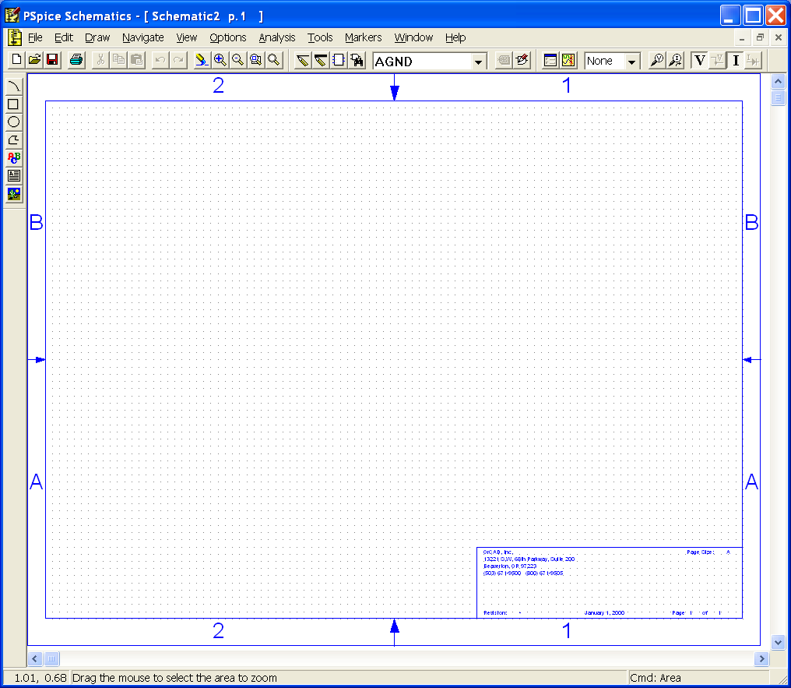

**II. Drawing the circuit:**

**A. Getting the Parts:**

* The first thing that you have to do is get some or all of the parts you need.
* This can be done by
  + Clicking on the 'get new parts' button new parts 
    icon, or
  + Pressing "Control+G", or
* Going to "Draw" and selecting "Get New Part..." Once this box is open, select a part that you want in your circuit. This can be done by typing in the name scrolling down the list until you find it

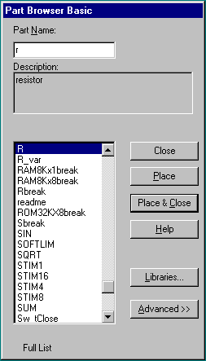

* Some common parts are:
  + r - resistor
  + C - capacitor
  + L - inductor
  + d - diode
  + GND_ANALOG or GND_EARTH -- this is very important, you MUST have a ground in your circuit
  + VAC and VDC
* Upon selecting your parts, click on the place button then click where you want it placed (somewhere on the white page with the blue dots). Don't worry about putting it in exactly the right place, it can always be moved later.
* Once you have all the parts you think you need, close that box. You can always open it again later if you need more or different parts.

**B. Placing the Parts:**

* You should have most of the parts that you need at this point.
* Now, all you do is put them in the places that make the most sense (usually a rectangle works well for simple circuits). Just select the part and drag it where you want it.
* To rotate parts so that they will fit in you circuit nicely, click on the part and press "Ctrl+R" (or Edit "Rotate"). To flip them, press "Ctrl+F" (or Edit "Flip").
* If you have any parts left over, just select them and press "Delete".

**C. Connecting the Circuit:**

* Now that your parts are arranged well, you'll have to attach them with wires.
* Go up to the tool bar and
  + select "Draw Wire" draw wire iconor
  + "Ctrl+W" or
  + go to "Draw" and select "Wire".
* With the pencil looking pointer, click on one end of a part, when you move your mouse around, you should see dotted lines appear. Attach the other end of your wire to the next part in the circuit.
* Repeat this until your circuit is completely wired.
* If you want to make a node (to make a wire go more then one place), click somewhere on the wire and then click to the part (or the other wire). Or you can go from the part to the wire.
* To get rid of the pencil, right click.
* If you end up with extra dots near your parts, you probably have an extra wire, select this short wire (it will turn red), then press "Delete".
* If the wire doesn't go the way you want (it doesn't look the way you want), you can make extra bends in it by clicking in different places on the way (each click will form a corner).

**D. Changing the Name of the Part:**

* You probably don't want to keep the names C1, C2 etc., especially if you didn't put the parts in the most logical order. To change the name, double click on the present name (C1, or R1 or whatever your part is), then a box will pop up (Edit Reference Designator). In the top window, you can type in the name you want the part to have.

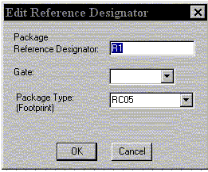

* Please note that if you double click on the part or its value, a different box will appear.

**E. Changing the Value of the Part:**

* If you only want to change the value of the part (if you don't want all your resistors to be 1K ohms), you can double click on the present value and a box called "Set Attribute Value" will appear. Type in the new value and press OK. Use u for micro as in uF = microFarad.   
  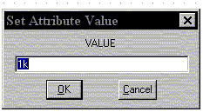
* If you double click on the part itself, you can select VALUE and change it in this box.
* 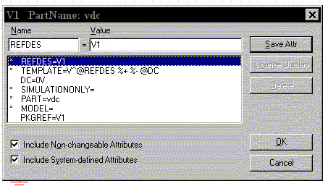

**F. Making Sure You Have a GND:**

* This is very important. You cannot do any simulation on the circuit if you don't have a ground. If you aren't sure where to put it, place it near the negative side of your voltage source.

**G. Voltage and Current Bubbles:**

* These are important if you want to measure the voltage at a point or the current going through that point.
* To add voltage or current bubbles, go to the right side of the top tool bar and select "Voltage/Level Marker" (Ctrl+M) voltage marker 
  iconor "Current Marker" current marker icon. To get either of these, go to "Markers" and either "Voltage/Level Marker" or "Current Marker".

**H. Saving:**

* To save the circuit, click on the save button save button 
  iconon the tool bar (or any other way you normally save files).

**I. Printing:**

* To print, you must first use your mouse to make a rectangle around your circuit, this is the area of the page that will be printed. Then select print as usual. (You can select print icon).

**III. Probe:**

**A. Before you do the Probe:**

* You have to have your circuit properly drawn and saved.
* There must not be any floating parts on your page (i.e. unattached devices).
* You should make sure that all parts have the values that you want.
* There are no extra wires.
* It is very important that you have a ground on your circuit.
* Make sure that you have done the [Analysis Setup](http://denethor.wlu.ca/PSpice/pspice_tutorial.html#anal) and that only the things you want are enabled.

**B. To Start the Probe:**

* Click on the Simulate button on the tool bar simulate 
  icon(or Analysis, Simulate, or F11).
* It will check to make sure you don't have any errors. If you do have errors, correct them.
* Then a new window will pop up. Here is where you can do your graphs.

**C. Graphing:**

* If you don't have any errors, you should get a window with a black background to pop up (even with errors, it will be OrCAD PSpice A/D Demo).
* If you did have errors, in the bottom, left hand side, it will say what your errors were (these may be difficult to understand, so go To "View - Output File").

**D. Adding/Deleting Traces:**

* PSpice will automatically put some traces in. You will probably want to change them.
* Go to Trace - Add Trace or add trace iconon the toolbar. Then select all the traces you want.
* To delete traces, select them on the bottom of the graph and push Delete.

**E. Doing Math:**

* In Add Traces, there are functions that can be performed, these will add/subtract (or whatever you chose) the lines together.
* Select the first output then either on your keyboard or on the right side, click the function that you wish to perform.

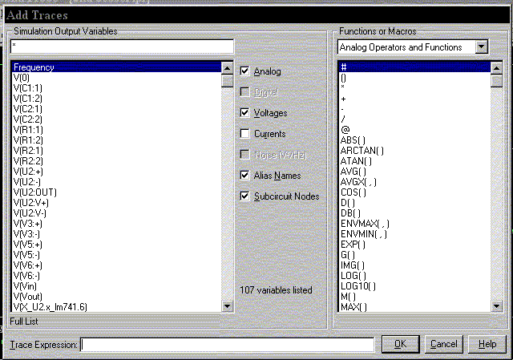

* There are many functions here that may or may not be useful. If you want to know how to use them, you can use PSpice's Help Menu.
* It is interesting to note that you can plot the phase of a value by using IP(xx), where xx is the name of the source you wish to see the phase for.

**F. Labelling:**

* Click on Text Label text label iconon top tool bar.
* Type in what you want to write.
* Click OK
* You can move this around by single clicking and dragging.

**G. Finding Points:**

* There are Cursor buttons that allow you to find the maximum or minimum or just a point on the line. These are located on the toolbar (to the right).
* Select which curve you want to look at and then select "Toggle Cursor" toggle cursor icon.
* Then you can find the max, min, the slope, or the relative max or min ( cursor function iconis find relative max).

**H. Saving:**

* To save your probe you need to go into the tools menu and click display, this will open up a menu which will allow you to name the probe file and choose where to save it. You can also open previously saved plots from here as well.

**I. Printing:**

* Select Print in Edit or on the toolbar print 
  icon.
* Print as usual.

**IV.** **Analysis Menu**

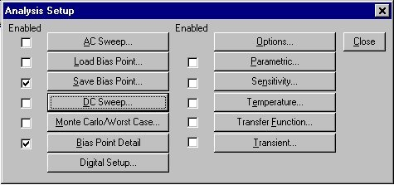

To open the analysis menu click on the analysis menu 
buttonbutton.

**A.** **AC Sweep**

* The AC sweep allows you to plot magnitude versus frequency for different inputs in your circuit.   
  In the AC sweep menu you have the choice of three types of analysis:
  + **Linear,**
  + **Octave and**
  + **Decade**.
* These three choices describe the X-axis scaling which will be produced in probe. For example, if you choose decade then a sample of your X-axis might be 10Hz, 1kHz, 100kHz, 10MHz, etc.... Therefore if you want to see how your circuit reacts over a very large range of frequencies choose the decade option.
* You now have to specify at how many points you want PSpice to calculate frequencies, and what the start and end frequency will be. That is, over what range of frequencies do you want to simulate your circuit.
* In the AC sweep you also have the option of **Noise enable** in which PSpice will simulate noise for you either on the output or the input of the circuit. These noise calculations are performed at each frequency step and can be plotted in probe.
* The two types of noise are:
  + V(ONOISE) for noise on the outputs and
  + V(INOISE) for noise on the input source.
* To use input noise you need to tell PSpice where you consider the 'input' in your circuit to be, for example, if your voltage source is labelled 'V1'.
* Finally you need to specify in what interval you want the noise to be calculated (note: the default interval for spice is zero, i.e.: no noise will be calculated).
* Example : Frequency response of simple RC circuit

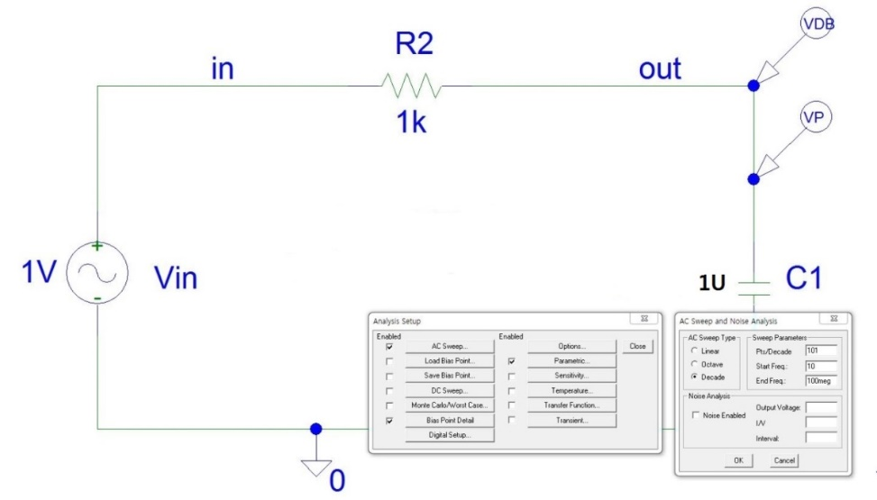

**B.** **DC Sweep**

* The DC sweep allows you to do various different sweeps of your circuit to see how it responds to various conditions.
* For all the possible sweeps,
  + voltage,
  + current,
  + temperature, and
  + parameter and global

you need to specify a start value, an end value, and the number of points you wish to calculate.

* For example you can sweep your circuit over a voltage range from 0 to 12 volts. The main two sweeps that will be most important to us at this stage are the voltage sweep and the current sweep. For these two, you need to indicate to PSpice what component you wish to sweep, for example V1 or V2.
* Another excellent feature of the DC sweep in PSpice, is the ability to do a **nested sweep**.
* A nested sweep allows you to run two simultaneous sweeps to see how changes in two different DC sources will affect your circuit.
* Once you've filled in the main sweep menu, click on the nested sweep button and choose the second type of source to sweep and name it, also specifying the start and end values. (Note: In some versions of PSpice you need to click on **enable nested sweep**). Again you can choose Linear, Octave or Decade, but also you can indicate your own list of values, example: 1V 10V 20V. **DO NOT** separate the values with commas.
* Example : I-V characteristic curves of 2N3904.
* (Main Sweep) :

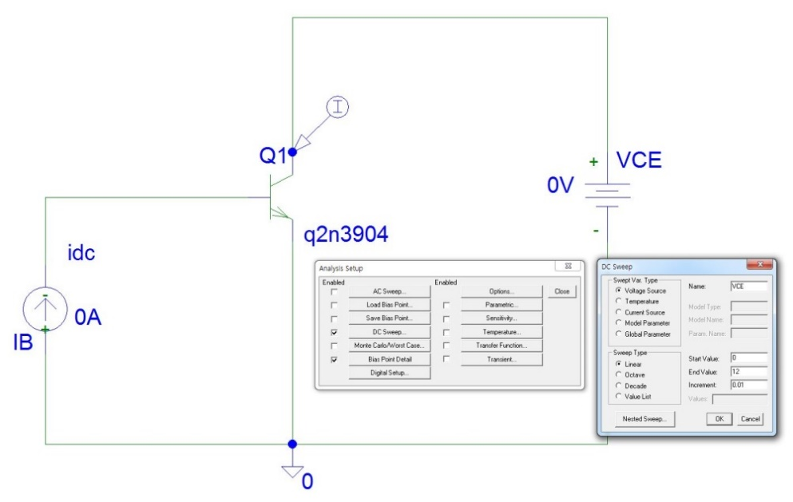

* (Nested Sweep) :

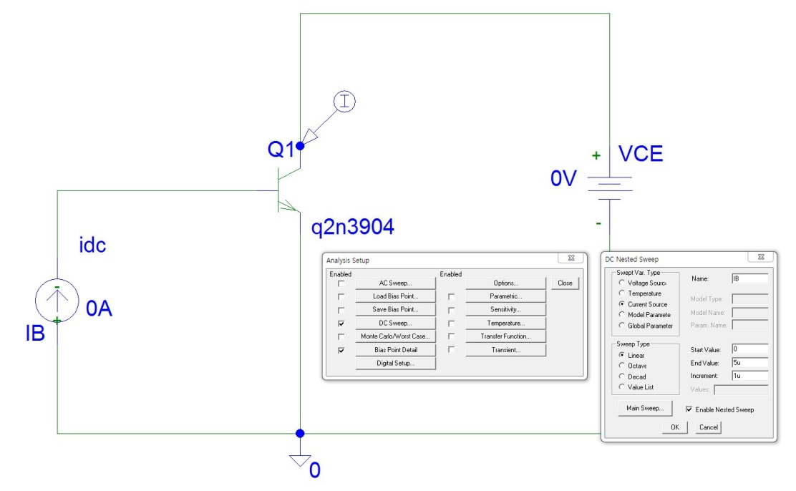

**C.** **Bias Point Detail**

* This is a simple, but incredibly useful sweep. It will not launch Probe and so give you nothing to plot. But by clicking on **enable bias current** **display** or **enable bias voltage display**, this will indicate the voltage and current at certain points within the circuit.
* Example : Bias voltages and currents of CE amp.

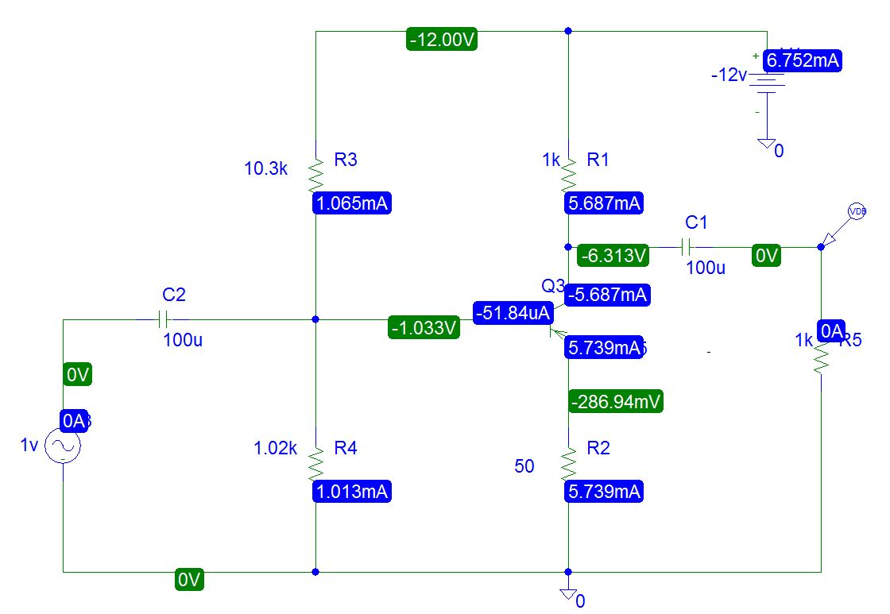

**D.** **Parametric**

* Parametric analysis allows you to run another type of analysis (transient, sweeps) while using a range of component values using the **global parameter** setting. The best way to demonstrate this is with an example, we will use a resistor, but any other standard part would work just as well (capacitor, inductor).
* First, double-click the value label of the resistor that is to be varied. This will open a "Set Attribute Value" dialog box. Enter the name **{RVAL}** (including the curly braces) in place of the component value. This indicates to PSpice that the value of the resistor is a global parameter called RVAL. In order to define the RVAL parameter in is necessary to place a global parameter list somewhere on the schematic page. To do this, choose "**Get New Part**" from the menu and select the part named **param.**
* Place the box anywhere on the schematic page. Now double-click on the word **PARAMETERS** in the box title to bring up the parameter dialog box. Set the NAME1= value to **RVAL** (no curly braces) and the VALUE1= value to the nominal resistance value. This nominal value is required, but it is only used if the DC bias point detail is computed. Otherwise, the value is ignored by PSpice.
* Finally, go to the "Analysis Setup" menu and enable "Parametric" analysis. Open the Parametric setup dialog box and enter the sweep parameters: Name: **RVAL** Swept variable type: Global Parameter. Make sure the other analysis type(s) are selected in the analysis setup menu (transient, sweeps). PSpice will now automatically perform the simulation over and over, using a new value for **RVAL** during each run.
* Example :

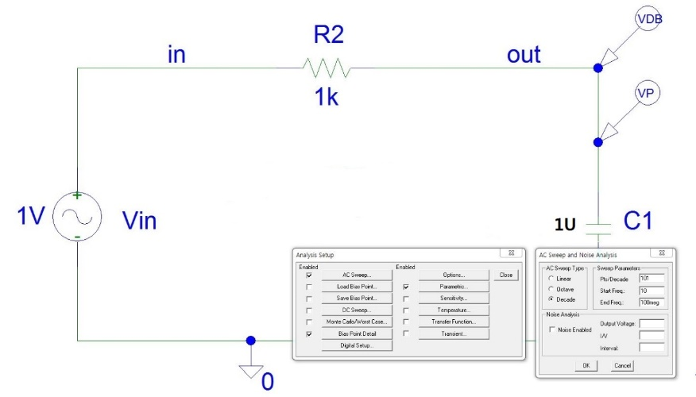

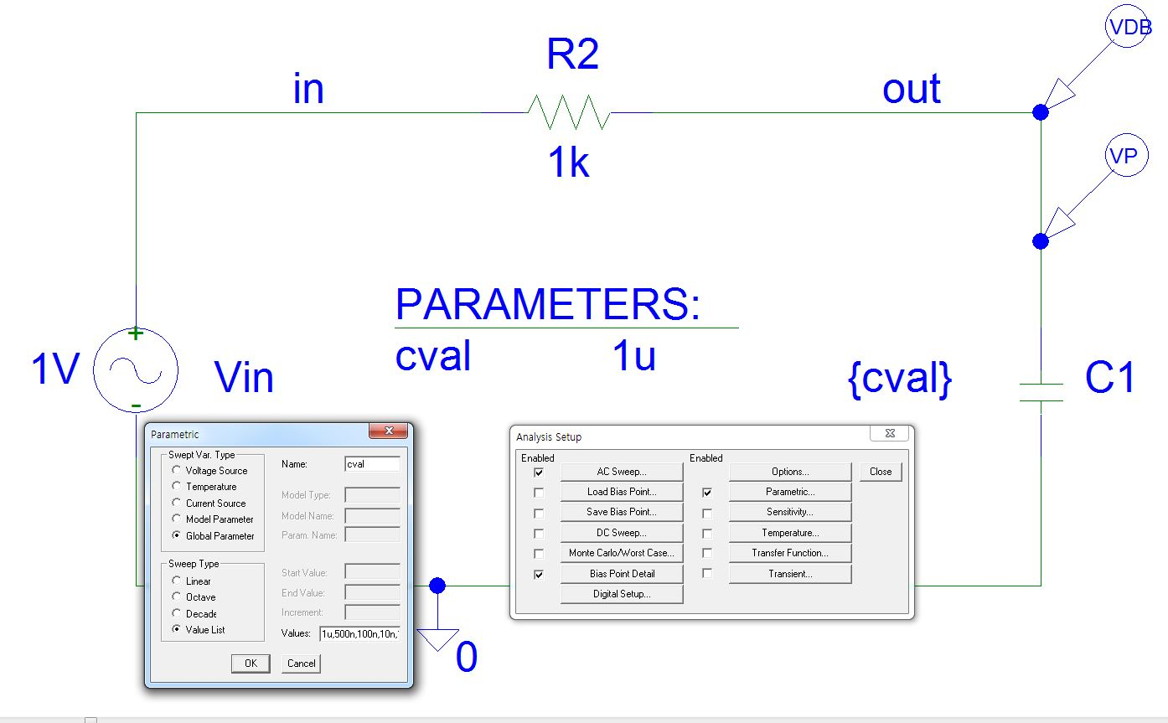

**E.** **Sensitivity**

* Sensitivity causes a DC sensitivity analysis to be performed in which one or more output variables may be specified.
* Device sensitivities are provided for the following device types only:
  + resistors,
  + independent voltage and current sources,
  + voltage and current-controlled switches,
  + diodes, and
  + bipolar transistors.
* You would use the sensitivity setting for discovering the maximum range of circuit performance and the causes of extreme operation. These techniques are used to identify effective changes to improve the quality of circuit operation (for example, which components need to have tight tolerance and which can be lower quality and less expensive).
* This isn't as important for us in the lab, but some day when you are constructing real circuits that need to function under various conditions this will be useful.

**F.** **Temperature**

* The temperature option allows you to specify a temperature, or a list of temperatures (do not include commas between temperature values) for which PSpice will simulate your circuit.
* For a list of temperatures that simulation is done for each specified temperature.

**G.** **Digital Setup**

* This paragraph will only indicate the features of the digital setup on the analysis menu, see below for a more complete description.
* In addition to letting you simulate analog circuits, PSpice provides a number of digital parts that can be used in a homogeneous digital circuit, or a heterogeneous analog/digital combination. The digital analysis option allows you to specify the timing of your circuit, by running the gates at their minimum, maximum and typical values. A superb feature allows you to test the worst case timing of your circuit to see how it will operate under these extreme conditions. You also have the option of setting the value of any flip flops you have in your circuit to predefined states which is good to simulate any startup conditions for finite state machines that you are simulating.

**H.** **Transient**

* The transient analysis is probably the most important analysis you can run in PSpice, and it computes various values of your circuit over time. Two very important parameters in the transient analysis are:
  + **print step**
  + **final time**.
* The ratio of **final time: print step** determines how many calculations PSpice must make to plot a wave form. PSpice always defaults the start time to zero seconds and going until it reaches the user defined final time. It is incredibly important that you think about what print step you should use before running the simulation, if you make the print step too small the probe screen will be cluttered with unnecessary points making it hard to read, and taking extreme amounts of time for PSpice to calculate. However, at the opposite side of that coin is the problem that if you set the print step too high you might miss important phenomenon that are occurring over very short periods of time in the circuit. Therefore play with step time to see what works best for your circuit.
* You can set a step ceiling which will limit the size of each interval, thus increasing calculation speed. Another handy feature is the Fourier analysis, which allows you to specify your fundamental frequency and the number of harmonics you wish to see on the plot. PSpice defaults to the 9th harmonic unless you specify otherwise, but this still will allow you to decompose a square wave to see it's components with sufficient detail.

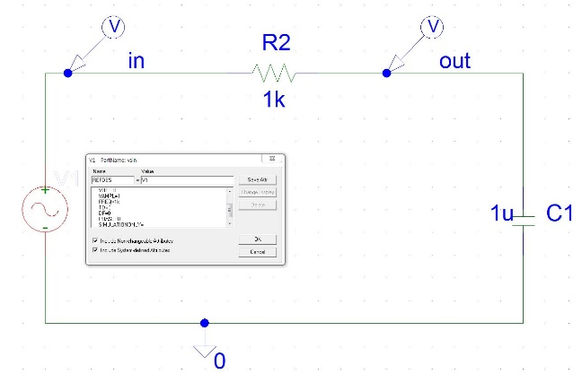 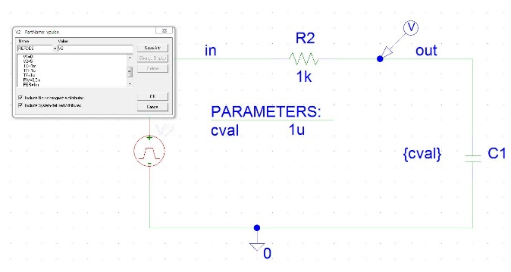

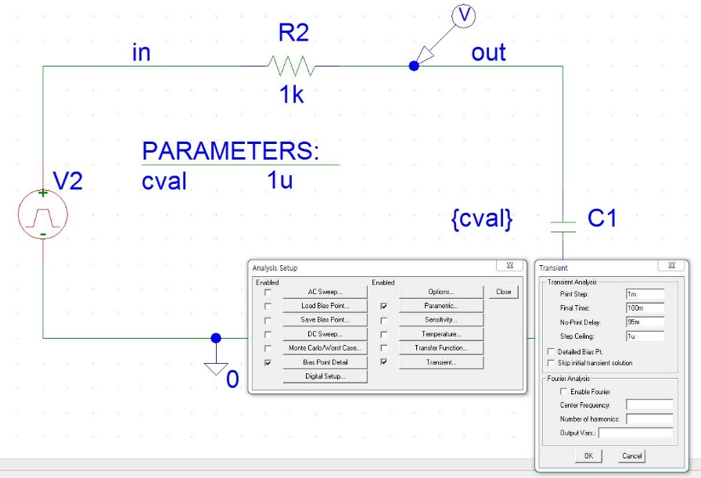

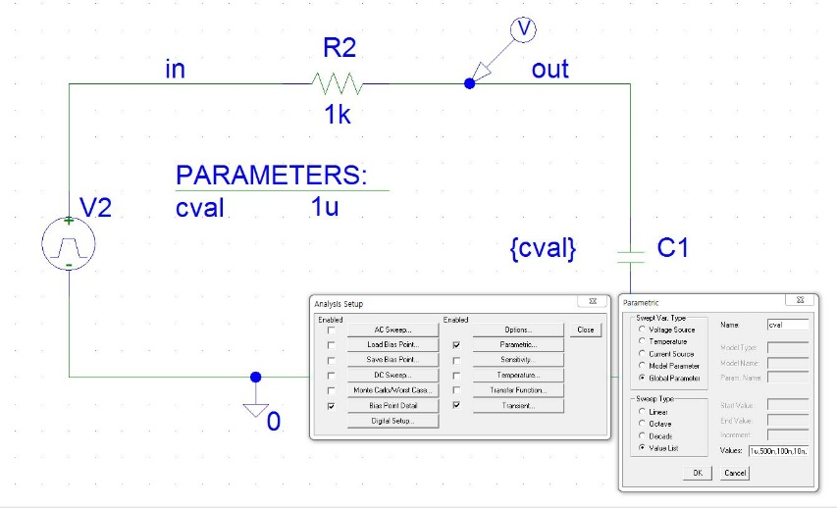

**V.** **Types of Sources**

**A.** **Voltage Sources**

**i.** **VDC**

* This is your basic direct current voltage source that simulates a simple battery and allows you to specify the voltage value.

**ii.** **VAC**

* A few things to note about the alternating current source, first PSpice takes it to be a sine source, so if you want to simulate a cosine wave you need to add (or subtract) a 90° phase shift. There are three values which PSpice will allow you to alter, these being:
  + **ACMAG** which is the RMS value of the voltage.
  + **DC** which is the DC offset voltage
  + **ACPHASE** which is the phase angle of the voltage
* Note that the phase angle if left unspecified will be set by default to 0°

**iii.** **VSIN**

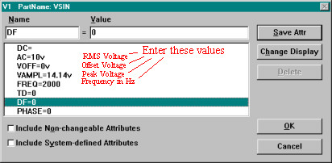

* The SIN type of source is actually a damped sine with time delay, phase shift and a DC offset. If you want to run a transient analysis you need to use the VSIN see how AC will effect your circuit over time. Do not use this type of source for a phasor or frequency sweep analysis, VAC would be appropriate for that.
  + **DC** the DC component of the sine wave
  + **AC** the AC value of the sine wave
  + **Voff** is the DC offset value. It should be set to zero if you need a pure sinusoid.
  + **Vamplitude** is the undamped amplitude of the sinusoid; i.e., the peak value measured from zero if there were no DC offset value.
  + **FREQ** is the frequency in Hz of the sinusoid.
  + **TD** is the time delay in seconds. Set this to zero for the normal sinusoid.
  + **DF** is the damping factor. Also set this to zero for the normal sinusoid.
  + **PHASE** is the phase advance in degrees. Set this to 90 if you need a cosine wave form.
* Note that the normal usage of this source type is to set **Voff**, **TD** and **DF** to zero as this will give you a 'nice' sine wave.

**iv.** **VPULSE**

* The VPULSE is often used for a transient simulation of a circuit where we want to make it act like a square wave source. It should never be used in a frequency response study because PSpice assumes it is in the time domain, and therefore your probe plot will give you inaccurate results.
  + **DC** the DC component of the wave.
  + **AC** the AC component of the wave.
  + **V1** is the value when the pulse is not "on." So for a square wave, the value when the wave is 'low'. This can be zero or negative as required. For a pulsed current source, the units would be "amps" instead of "volts."
  + **V2** is the value when the pulse is fully turned 'on'. This can also be zero or negative. (Obviously, V1 and V2 should not be equal.) Again, the units would be "amps" if this were a current pulse.
  + **TD** is the time delay. The default units are seconds. The time delay may be zero, but not negative.
  + **TR** is the rise time of the pulse. PSpice allows this value to be zero, but zero rise time may cause convergence problems in some transient analysis simulations. The default units are seconds.
  + **TF** is the fall time in seconds of the pulse.
  + **TW** is the pulse width. This is the time in seconds that the pulse is fully on.
  + **PER** is the period and is the total time in seconds of the pulse.
* This is a very important source for us because we do a lot of work with the square wave on the wave generator to see how various components and circuits respond to it.

**v.** **PWL (Piece-Wise Linear)**

* The PWL source is a Piece Wise Linear function that you can use to create a wave form consisting of straight line segments drawn by linear interpolation between points that you define. Since you can use as many points as you want, you can create a very complex wave form This source type can be a voltage source or a current source.
* The syntax for this source type is flexible and has several optional parameters. The required parameters are two-dimensional points consisting of a time value and a voltage (or current) value. There can be many of these data pairs, but the time values must be in ascending order, and the intervals between time values need not be regular.
* The two optional parameters are "DC" and "AC." The use of an AC parameter with this source is not very well documented and because this source is intended for use with a transient analysis any AC value would be ignored.

**B.** **Current Sources**

* For any of the previous discussed voltage sources, there exist the exact source except that they produce current. There is one thing that should be mentioned; current sources in PSpice get a little confusing. For those current sources whose circuit symbol has an arrow, you have to point the arrow in the direction of conventionally flowing current. This applies to all current sources, including AC and DC. Therefore placing the current source in the circuit backwards with seemingly incorrect polarities will give the correct results.
* An interesting little feature under the **markers** menu is the ability to add markers to your circuit so you can see where the current and voltage have imaginary values in the circuit, and the phase of your source at any point in the circuit.